🏢 Meet Company A
Company A is a tech-driven business owned by a larger company that funds them based on their profits. They make money primarily from advertising products on their website and app. And surprise—turns out, the app is the superstar here, pulling in way more traffic and revenue than the website. Think of the app as the popular kid, and the website as its forgotten sibling.
🦸‍♂️ Enter our protagonist: the Lead Data Science and Engineering Manager. This guy is basically the glue holding the app’s success together. He oversees two teams: the Data Science Team and the App Development Team, both working tirelessly to improve the app, engage users, and generate big bucks from advertising.
The manager has been strategic - recruiting the right talent, assigning tasks based on strengths, and hiring a QA specialist to keep things smooth. His efforts resulted in a 40% increase in revenue thanks to smart AI solutions and customer-centric strategies. Basically, he’s crushing it.
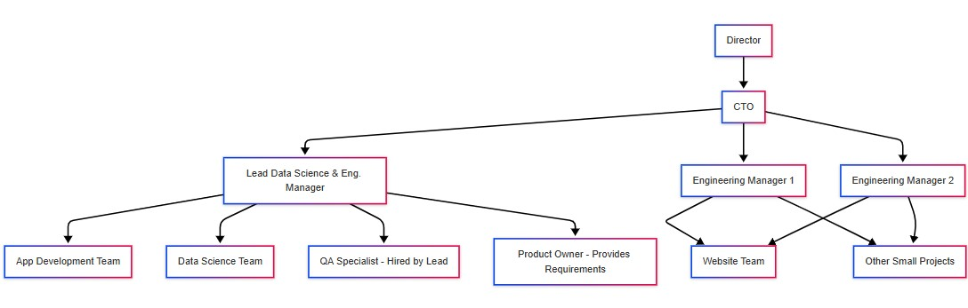
Below is company’s A organisational flowchart for your reference

But wait for it... the Lead Data Science & Engineering manager handed in his notice. (Cue dramatic gasp…)
Three months - that’s how long they have before he walks out the door for good. You’d think that would be enough time to plan for a smooth transition, right?
The CTO and Director decide - within one week - to split his teams between the two other Engineering Managers. No offense to these managers, but they know nothing about Data Science or AI. Meanwhile, the Lead Data Science and Engineering manager was reassigned to work on solo projects.

The app developers and data scientists, now reporting to unfamiliar managers, were left adrift. No one had taken the time to analyse the new team structure, assess their workloads or individual strengths before assigning new responsibilities. The CTO and Director did not establish any future-proofing or contingency plans, despite being provided with Project Monitoring KPIs indicating that the required workload exceeds available resources.
As a result, both the app developers and the data scientists lacked clarity about their responsibilities and the direction of their work. Tasks piled up, deadlines were missed, and team members began leaving. In fact, one person had quit every month, and still, no staff replacement in sight.

The Director and CTO decided to pause all work on the app indefinitely. Both the Director and CTO agreed that the departure of the Lead Data Science and Engineering Manager necessitated a shift in the company's data strategy. As a result, they decided to lower the KPIs and targets for the financial year ending on March 31, 2025. The updated figures have yet to be disclosed so the new targets hadn’t been communicated to the teams yet.

However, a transformation project to re-design the website has started, despite not being part of the year's original technical roadmap. There is no SWOT analysis, no market research, and no proof of concept to see if users even wanted a redesigned website. There was no analysis of how much time, money, or resources the project would require. It was a leap of faith, and they were flying blind.

The web designs have not yet been finalised, nor has a clear data strategy been determined for how the website will collect customer data to generate insights that will drive more traffic.
The Data Science Team was asked to “work their AI magic” and develop algorithms for the new website. But when the data scientists asked for more information about the planned changes, their new managers scratched their heads and offered responses: “Just, you know, do some AI things,” they said. The data scientists weren’t amused.

Senior Data Scientists and Senior Developers raised concerns about the lack of direction, but instead of being heard, they were reprimanded during one-on-one meetings. Some were told to “stay in their lane” and stop questioning decisions.

With the Lead Data Science and Engineering Manager’s departure date fast approaching, no one knew who would take over his responsibilities.

Now it’s your turn to step in. You’ve been hired as consultants to help this company navigate its current crisis and rebuild its data culture. The clock is ticking. The fate of Company A rests in your hands. Good luck!
Discuss in your groups
🧐 What are the key issues affecting Company A’s data culture?
🧐 What went wrong after the Lead Data Science and Engineering Manager resigned?
🧐What steps would you suggest the Director and CTO take to fix this situation?

